
Assistant Professor Andrie Panayiotou is an epidemiologist with interests in the epidemiology of cardiovascular disease. Her work focuses on identifying risk factors and biomarkers which can be used to better identify individuals with pre-clinical atherosclerosis. The identification and early treatment of such individuals is essential to the success of efforts to reduce the impact of ischemic heart disease on mortality and morbidity in Cyprus.

Since joining CII in 2011, Dr. Panayiotou has established the Cardiovascular Epidemiology and Genetics Research Laboratory (http://www.cut.ac.cy/faculties/hsc/cii/).
Title Public Health Assistant Professor

Daphne Kleopa
PhD student
Research Associate

Ms. Daphne Kleopa is a Public Health Nutritionist with a BSc (Hons) in Bioscience Nutrition. She holds an MSc in International Public Health Nutrition and an MSc in Epidemiology and Biostatistics. She is a current PhD Student at the School of Public Health
(Department of Nursing / Cyprus International Institute for Environmental and Public Health).
Her research interests include nutritional and geographical epidemiology, health inequalities and the social and physical determinants of health.



Galatia Photiou
PhD student
Research Associate
Ms. Galatia Photiou is a Mathematician with a BSc in Mathematics from University of Crete. She holds an MSc in Environmental Health from Cyprus International Institute for Environmental and Public Health in association with the Harvard School of Public Health. She is a current PhD Student in the Environmental Health offered by the Cyprus International Institute for Environmental and Public Health/Cyprus University of Technology.
Her research interests include the fields of biostatistics and epidemiology.



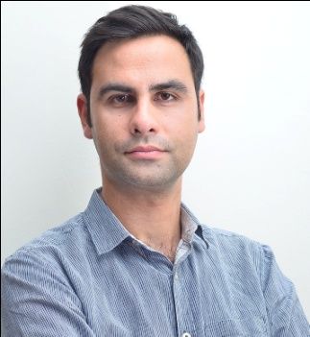

PhD Student
Research Associate
Elena Hadjimbei graduated from the Department of Science of Nutrition and Dietetics, at Harokopio University of Athens in 2003. She completed her postgraduate studies in Clinical Nutrition at the University of Glasgow, as a fellow of the Institute Harokopou in 2005. Since 2014, she is a PhD candidate at the Cyprus University of Technology at the Department of Agricultural Sciences, Biotechnology and Food Science.
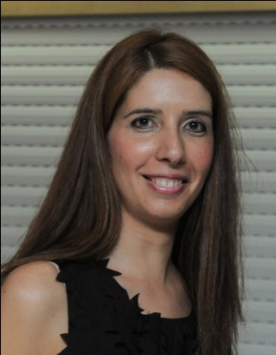

Andreas Kousios MD
Research Associate


Dr Andreas Kousios is a practicing Nephrologist and holds an MSc in Molecular Medicine. Currently, he is working as a Clinical Research Fellow at Imperial College NHS Trust. His research interests include Cardiovascular disease associated with Chronic Kidney Disease and paraprotein related renal diseases.

Mary Economou- Dietician/Research Associate
Yiota Socratous-Research Associate

