European Observatory on Femicide (EOF)- Leaflet
Femicide – the gender-motivated killing of women – is preventable. Femicide is the most extreme manifestation of gender based violence against women. Data and improved knowledge on femicide and empowerment of women have the potential to save women’s lives.

The European Observatory of Femicide (EOF) is the first European-wide network established with the aim of monitoring cases of femicide and contributing to the prevention of femicide and has resulted from the 2014-2017 European Union funded COST Action on Femicide across Europe.

The European Observatory on Femicide (EOF) is research network and is currently coordinated jointly by two institutions: the Cyprus University of Technology (CUT) and the Institute for Empirical Sociology (IfeS) at the Friedrich-Alexander-University Erlangen Nürnberg in Germany (since January 2020). The EOF was initially hosted at the University of Malta from January 2018 until December 2019. The coordination of the EOF is supported by an international Advisory board of experts on femicide.
The coordination and the advisory board of the EOF are (from left to right):


Chaime Marcuello – University of Zaragoza – Spain
Christiana Kouta – Cyprus University of Technology – Cyprus
Consuelo Corradi – University LUMSA in Rome – Italy
Ksenia Meshkova – Humboldt University of Berlin – Germany
Marceline Naudi – University of Malta – Malta
Maria Jose Maghalaes – University of Porto – Portugal
Monika Schroettle – Institute of Empirical Sociological Research - Germany
Santiago Boira – University of Zaragoza – Spain
Shalva Weil – Hebrew University of Jerusalem – Israel

The EOF’s mission aligns with the international consensus on the necessity to provide high quality data on violence against women and femicide.

Mission Statement
The mission of the European Observatory on Femicide (EOF) is first and foremost the prevention of femicide through data collection, data visibility, research and awareness raising. This mission will be kept at the forefront of all the EOF work. The EOF recognises its serious duty and obligation, as the first Observatory of its kind in Europe, to lead by setting an example of high standard, innovative and collaborative research initiative.

The EOF recognises past and current efforts in Europe and around the world to prevent and combat violence against women and femicide, and fully commits to meaningful partnerships with stakeholders in the field, including women’s NGOs, governmental bodies, agencies and institutions.

In its mission, the EOF aligns itself with the efforts of the international community to address violence against women and femicide, including in support of monitoring the implementation of the Council of Europe Convention on preventing and combating violence against women and domestic violence (2011), and the efforts of the European Union to eradicate violence against women, and contributing in its work to the Femicide Watch Platform.

The EOF seeks to represent all women victims regardless of their background or status. The EOF recognises that the accessibility and visibility of data is an indication of state accountability for the protection of women and the prevention of femicide.

Principles
- Accessibility and visibility of data – while promoting the release of official data on femicide, the EOF will make its data accessible to others working in the field of femicide prevention.
- Outreach and advocacy – the EOF will actively raise awareness about femicide as well as respond to opportunities and challenges in the field of femicide prevention as they arise.
- Collaboration – the EOF will actively engage with relevant stakeholders in the field through equal exchanges and empowering partnerships.
- Inclusiveness and diversity – the EOF seeks to engage all relevant sectors, including NGOs, academics, governments, and others. The EOF seeks to count all victims of femicide regardless of background or status.
- Innovation – the EOF’s research and activities aim to be innovative for the sake of effectiveness and efficiency.
- Empowerment of women – the EOF acknowledges that violence against women is rooted in the imbalance of power between women and men and its work is guided by the need to create an equal society as part of effective preventive frameworks.
Core Activities
Specific researchers from the EOF advisory board are responsible for organising the methodology for data collection under two thematic groups: data collection (mainly quantitative research) and prevention (mainly qualitative research). The EOF will operate through the setting up and supporting of Europe-wide country research groups that will act as focal points for the collection, joint analysis and dissemination of data. This will be coordinated through the work of the two thematic groups.

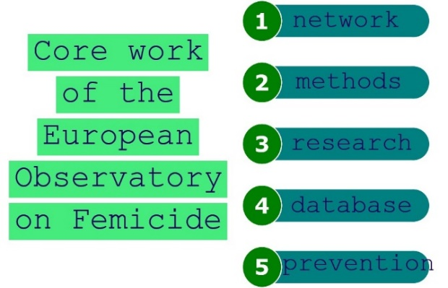
(1) As one of our main activities, we are working to develop a European wide network of country research groups composed of NGOs, government agencies, academics, and journalists. At the moment, the Observatory has 23 country research groups committed to forming part of the network and contributing to the research.

(2) We have developed comparative quantitative and qualitative methods to count femicides and study femicide cases. These methods (or data collection tools) are transnational and meant for continuous research. Both of the research tools build upon previous work in the field, are unique to the EOF, and simplified for easy use by a large group of researchers.

(3) We aim to count the number of femicides in Europe and also highlight the areas of society (from individuals to communities to institutions and to societal norms) that must change in order to prevent femicides. Our research begun with a pilot to make sure that the data collection tools work for each country and that the results provide

important discoveries that can be transformed into impactful prevention strategies. We expect that the research will encourage government agencies to start collecting better data on violence against women.

(4) One especially innovative aspect of the EOF is to create a virtual database on cases of femicide in order to allow all of the researchers and professionals involved in the Observatory to have access to the information and to conduct their own studies and analysis, which may additionally pick up on preventive elements that can be missed in broader annual studies. The virtual database is also meant to promote the practice of transparency, and data sharing and availability.

(5) EOF’s preventive work will take different shapes and involve different steps, including using social media to bring the researchers and their findings closer to the general public, writing letters to governments, conducting institutional trainings, and collaborating with journalists to publish articles and videos on the topic of femicide. In order to prevent femicide, everyone will need to be informed.The EOF will work alongside policy makers, national, European, and international institutions to endorse EOF’s recommendations in order to create greater political will toward making changes in the system that will benefit women victims of domestic violence, to save their lives and live a future free from violence.

Each year, in Europe, thousands of women are killed in the context of domestic violence. This not only creates immediate trauma to their family members, including children, but also their friends and communities. With enough knowledge and political will, femicide is preventable!

Femicide prevention saves lives, but also involves addressing other forms of discrimination and violence against women. For this reason, prevention work greatly improves the overall wellbeing of women and girls, and society as a whole by tackling harmful gendered norms and expectations.

